DSA06 Data Handling and Visualization
Class Activity 3: Time Series in R and Tableau (35 marks) | Slot D
R.No: 4 Reg. No: 192324305 Name: AYESHA SIDDIQA S
data (three branches, 36 months, Jan 2023 to Dec 2025; Sales in Rs lakh)
set.seed(47068)
branch <- c("Mylapore", "Velachery", "Porur")
n <- 36; month_no <- 1:n
date <- seq(as.Date("2023-01-01"), by = "month", length.out = n)
base <- c(75, 60, 130); growth <- c(0.8, 0.4, 1.2); amp <- c(6, 3, 4); peak_month <- 6
sales <- sapply(1:3, function(i) round(base[i] + growth[i] * month_no + amp[i] * cos(2 * pi * (month_no - peak_month) / 12) +
rnorm(n, 0, 2), 1))
df <- data.frame(Month = rep(date, 3), Month_no = rep(month_no, 3), Branch = rep(branch, each = n), Sales = as.vector(sales))
write.csv(df, "ts_data.csv", row.names = FALSE) # use this file in Tableau

R1 Draw a multiple time-series chart of the three branches (one colour each, direct labels instead of a legend). Fit lm(Sales ~ Month_no) for each branch; report the three slopes per month and name the fastest-growing branch. [3]
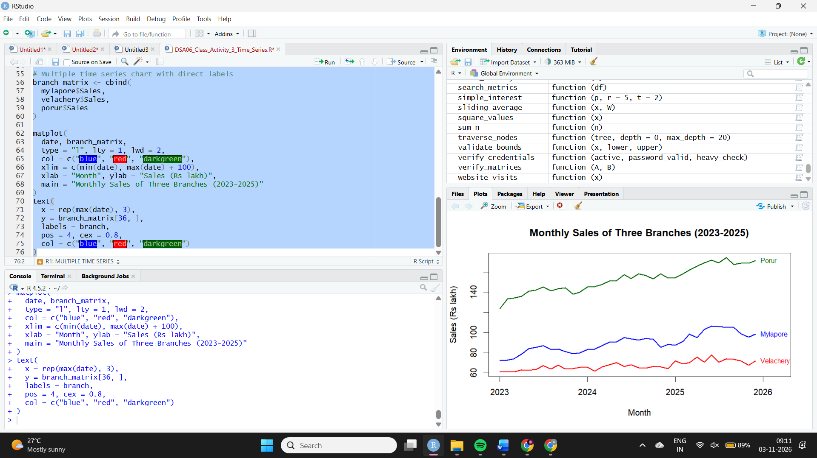
R2 Convert the first branch (Mylapore) to ts(frequency = 12, start = c(2023, 1)) and run stl(x, "periodic"). Plot it, report the peak and trough months of the seasonal part and the strength of seasonality F_s = max(0, 1 - var(remainder) / var(seasonal + remainder)). [4]
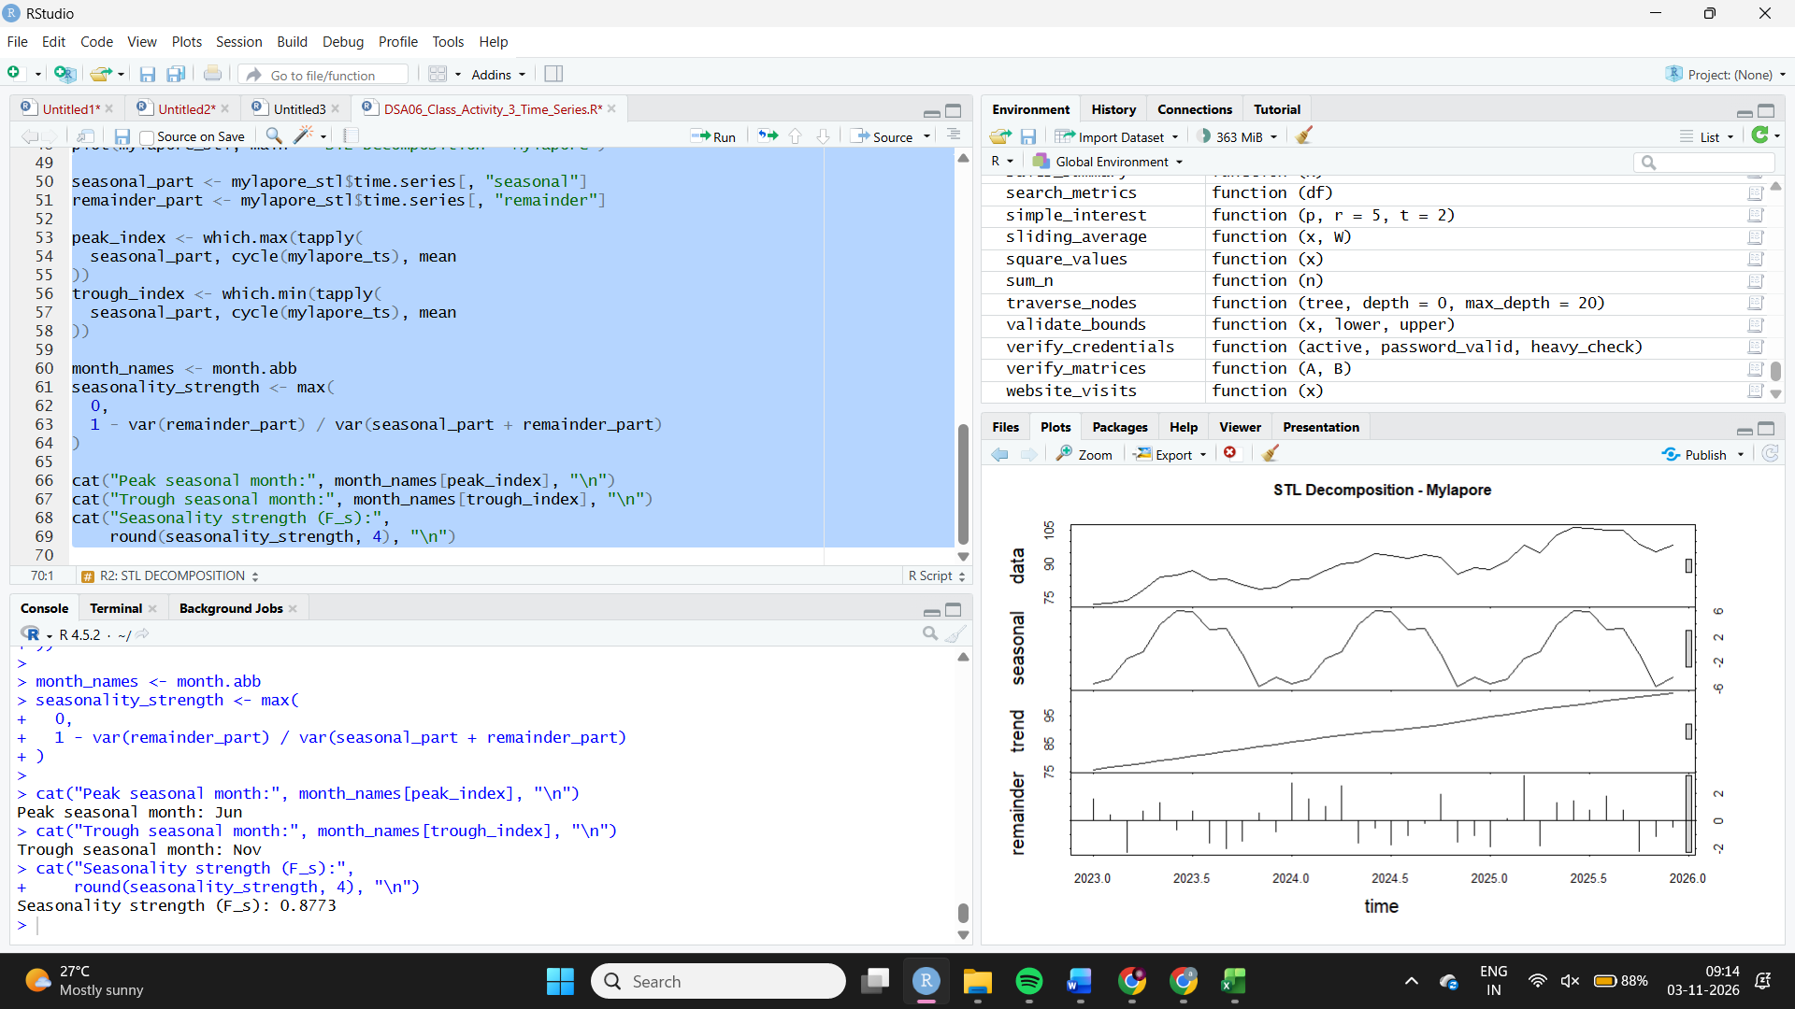
R3 Add the three branches together month by month (total Sales). Draw the total with a 3-month and a 12-month trailing moving average (stats::filter, sides = 1). Report both averages at month 24 and say which lags more and why. [4]
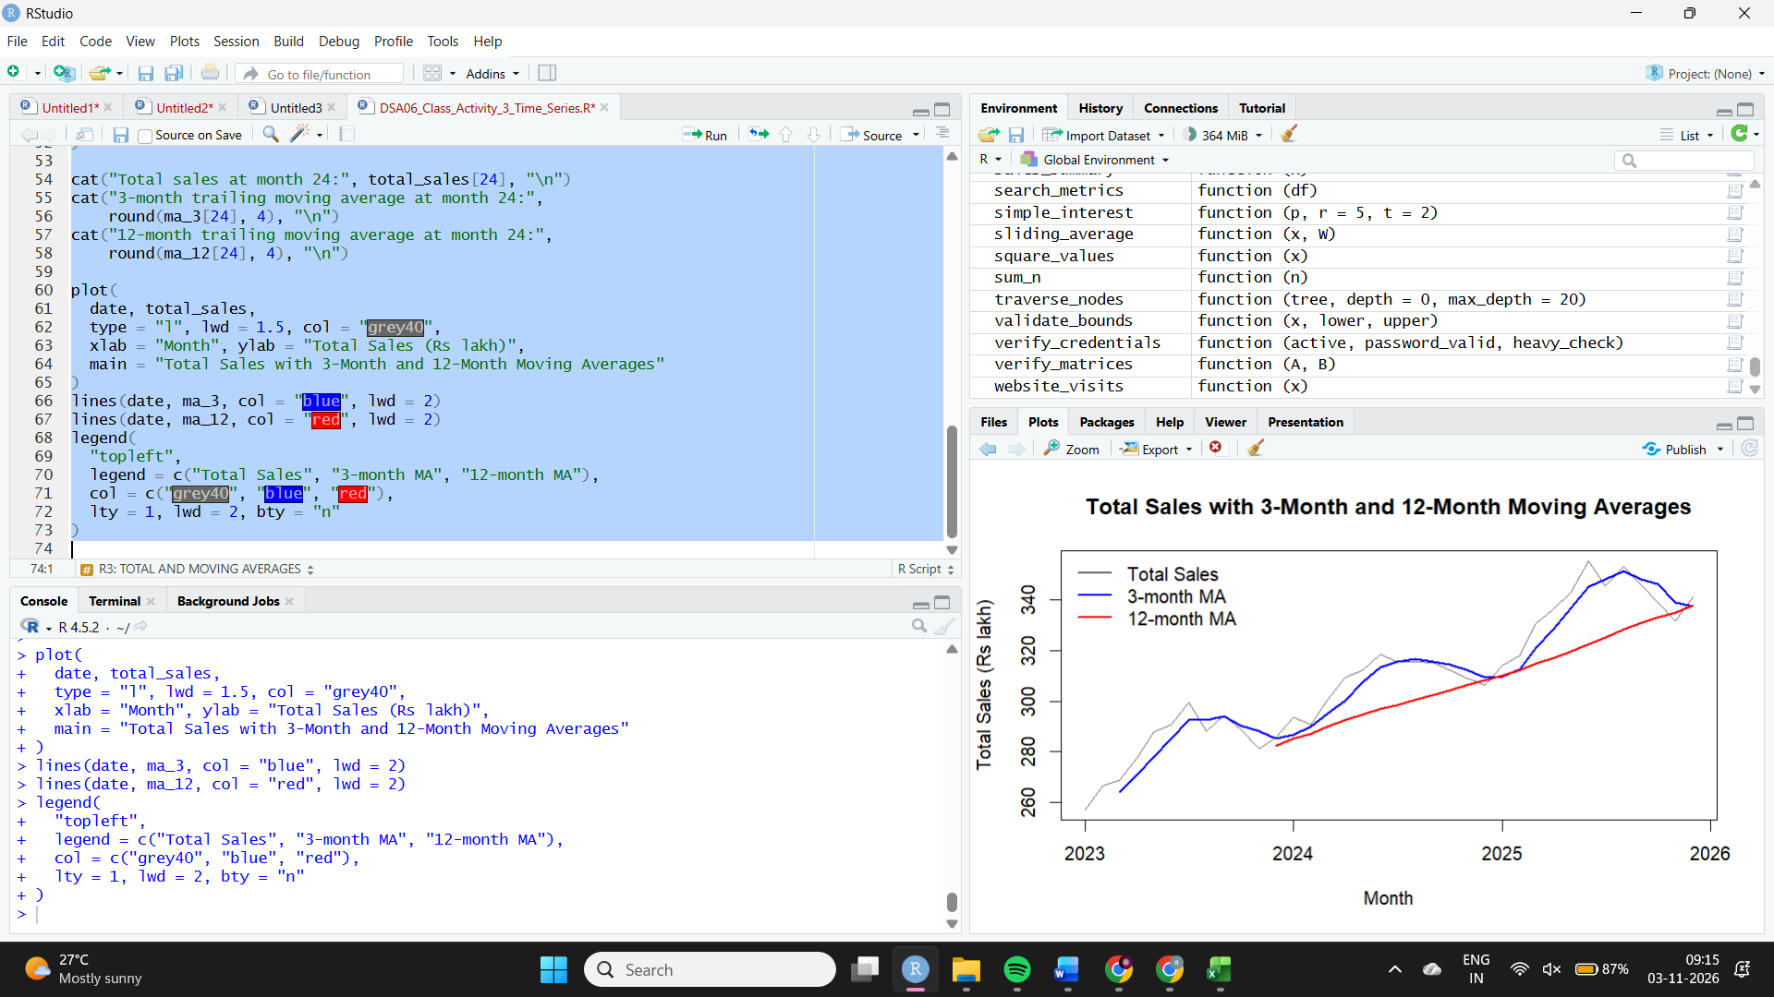
R4 Take the second branch (Velachery). Remove its linear trend (residuals of lm), draw acf(residuals, lag.max = 14), report the autocorrelation at lag 12 and compare it with the bound 1.96 / sqrt(36). Is there a yearly cycle left? [4]
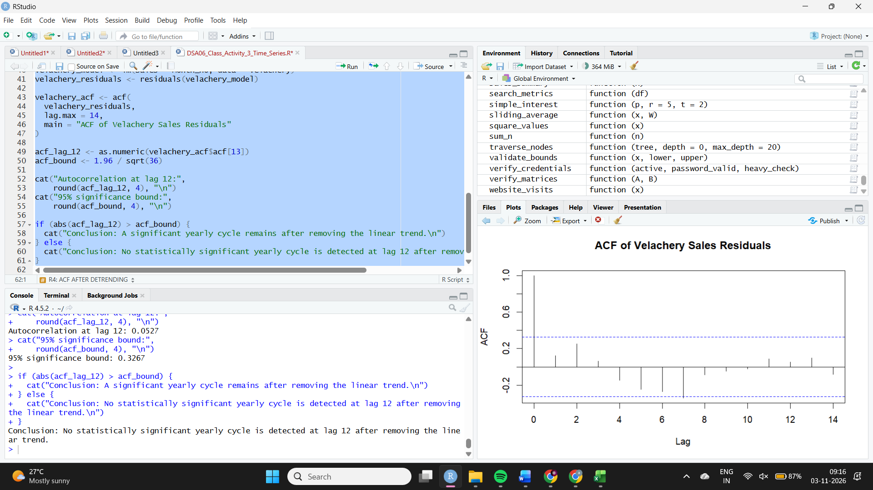
R5 For the first branch fit HoltWinters on months 1 to 30, forecast months 31 to 36 with predict(..., prediction.interval = TRUE), and draw the history, forecast and band. Report the MAPE against the real months 31 to 36 and the width of the 95% band at h = 1 and h = 6. [5]
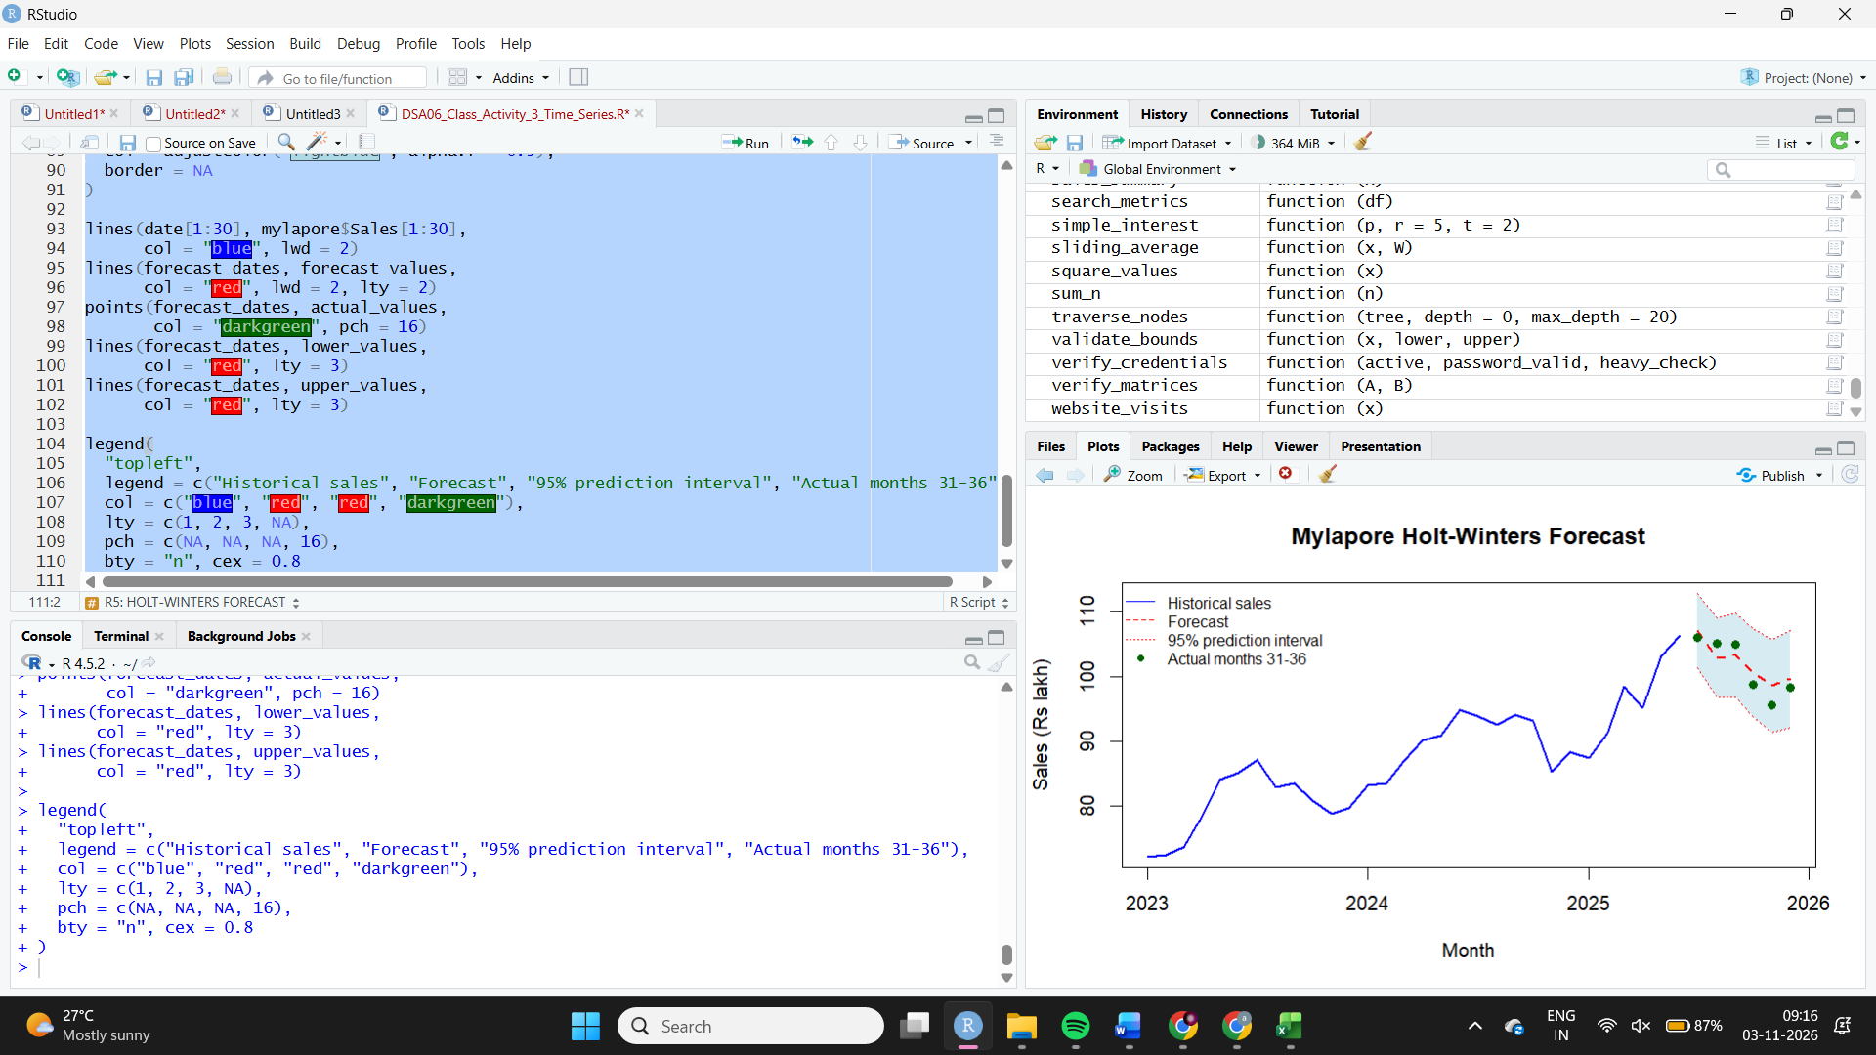
Part 2. Tableau Public
T1 Connect to your CSV and build a line chart of Sales by Month with one coloured line per Branch. Report which branch has the highest Sales in Dec 2025 and its value (hover over the last point). [3]
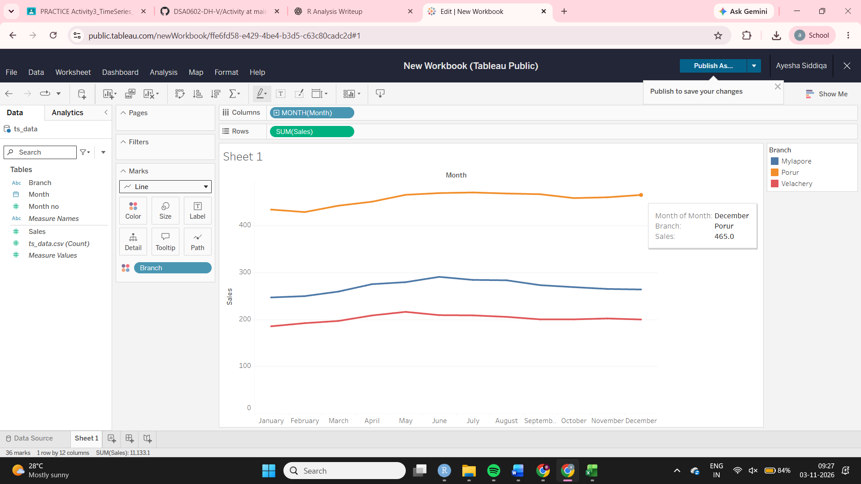
T2 Add a linear trend line (Analytics tab > Trend Line > Linear) so that there is one line per branch. For each branch use Describe Trend Model to read R-squared; name the branch with the highest and the lowest R-squared. [4]
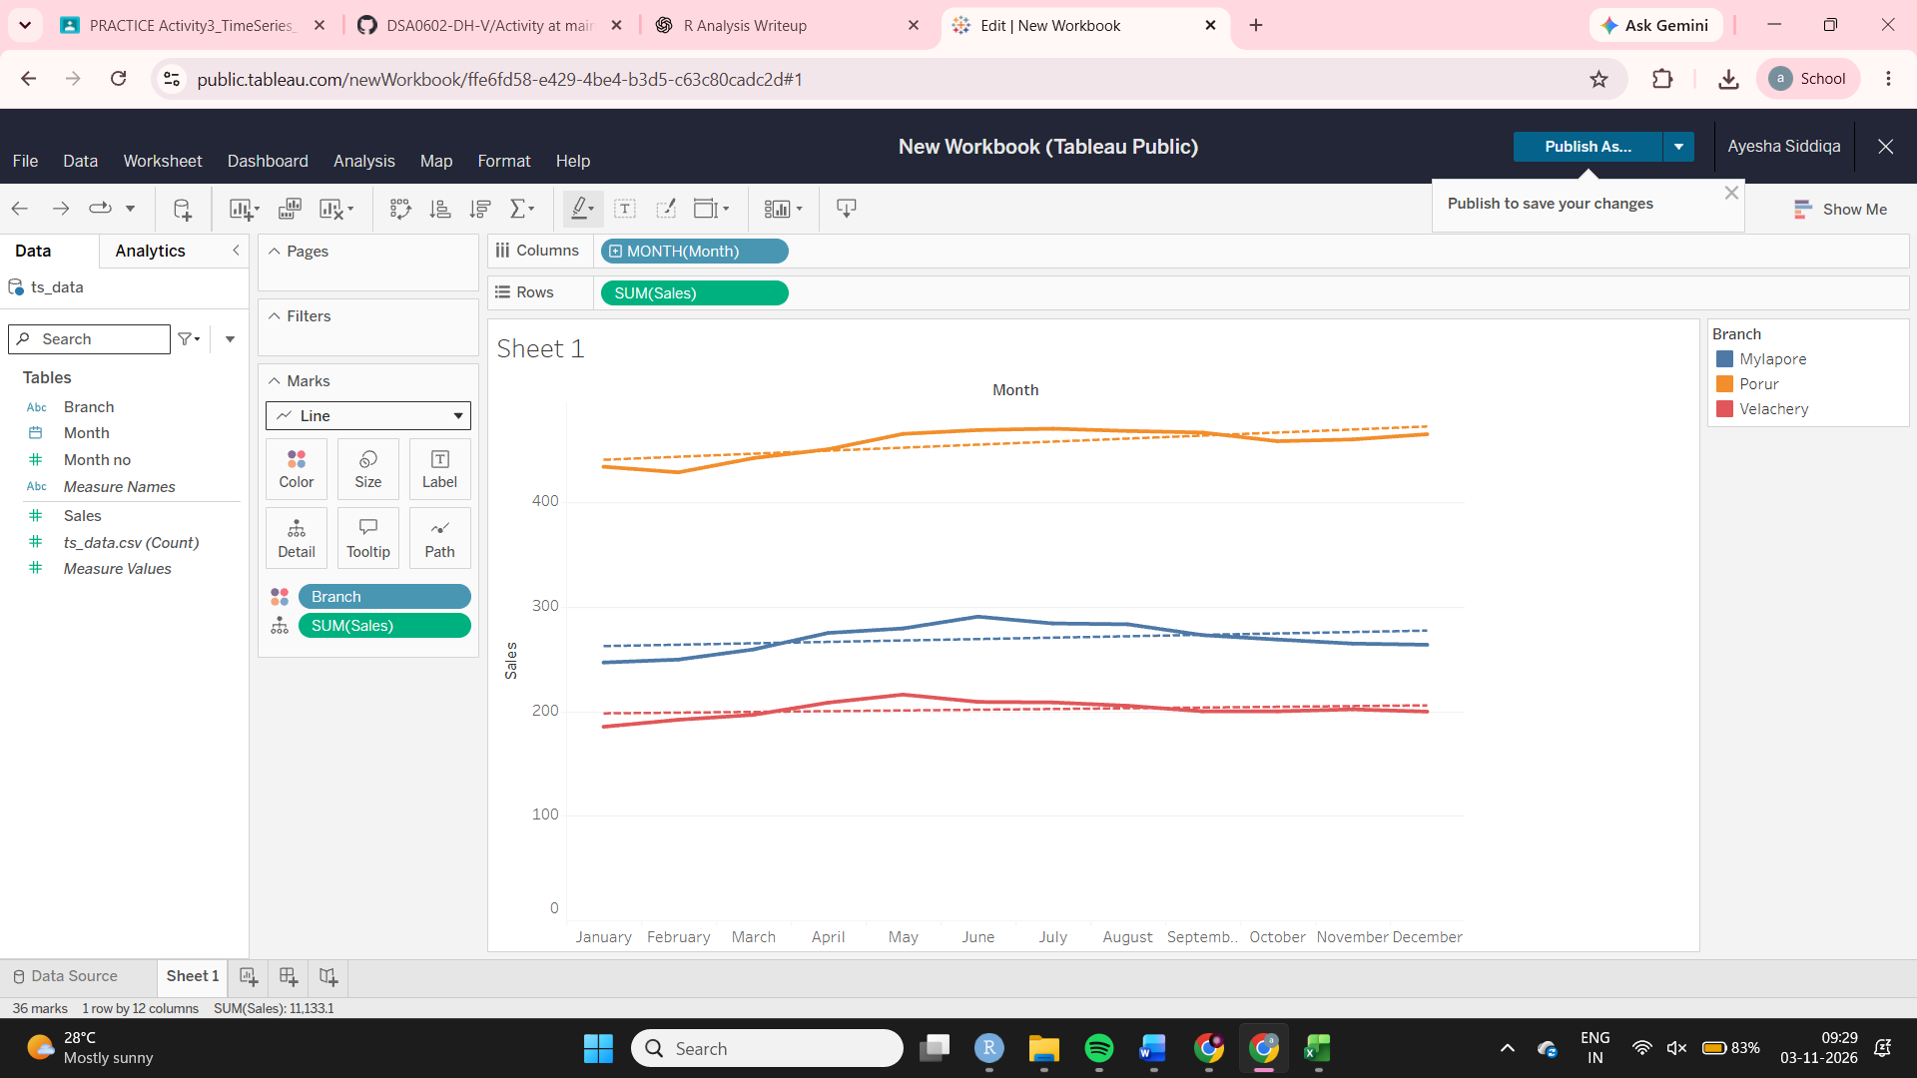
T3 Make a new sheet with total Sales by Month (no Branch). Right-click the SUM(Sales) pill > Quick Table Calculation > Moving Average and read the value at Dec 2024 (month 24). Compare it with your R3 answer. [4]
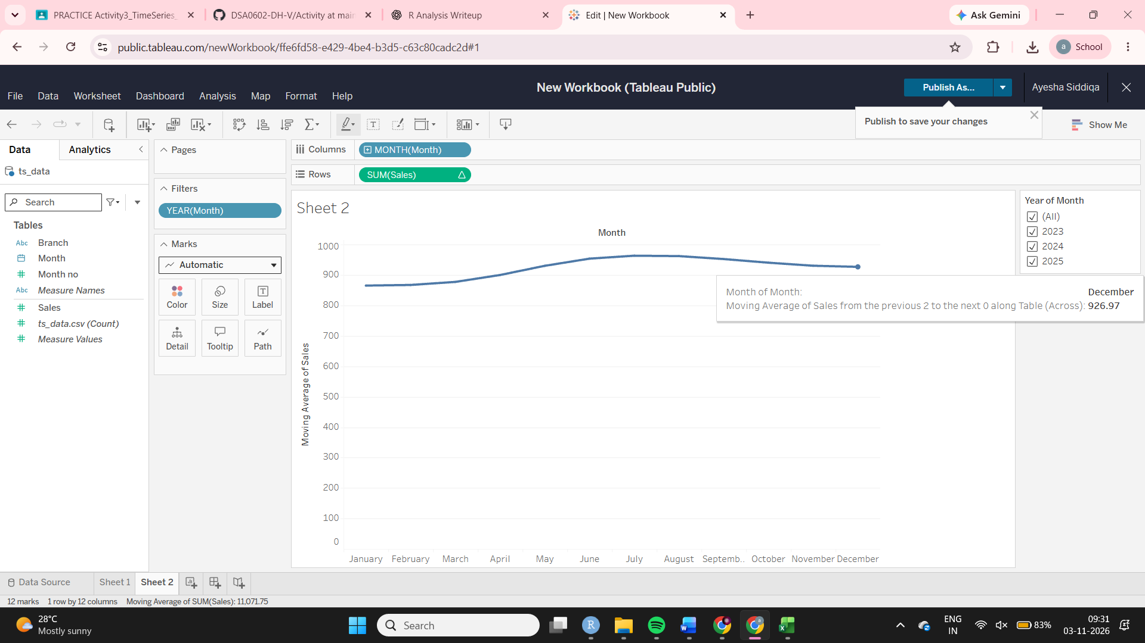
T4 On the same total-Sales sheet change the table calculation to Percent Difference (Quick Table Calculation). Report the value for Dec 2025. [2]
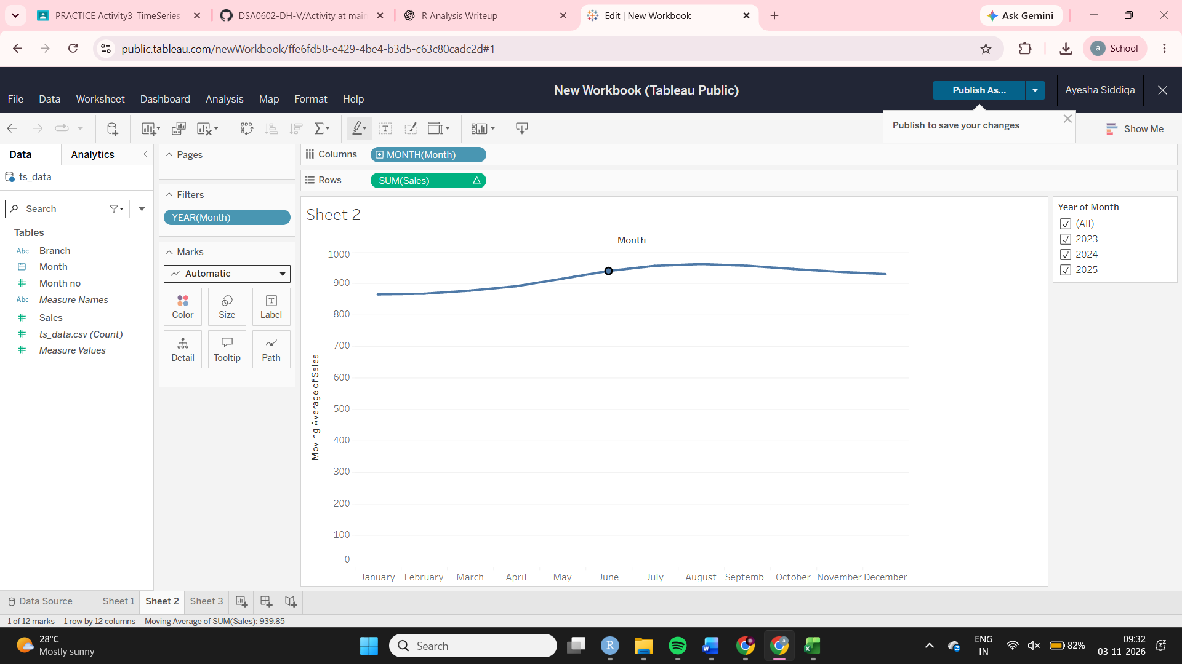
T5 Write two real differences between doing this analysis in R and in Tableau, using what happened in your own work today. [2]

